3-Phase AC Power Metering (ADE9078 IC Chipset)

Jumper Configuration

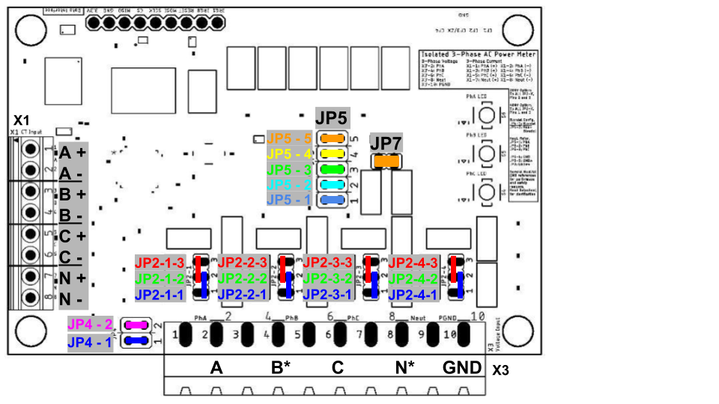

Figure 1. Visual Representation of Jumpers

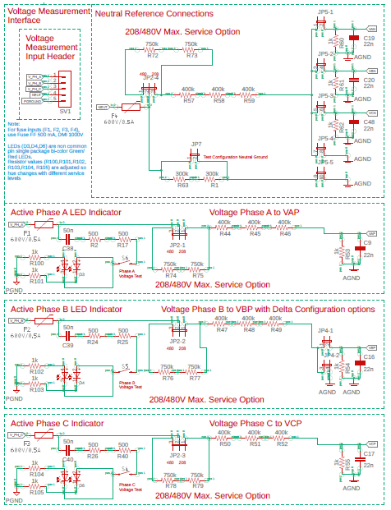

Figure 2. Circuit reference for Jumper functionality

|  |  |
| --- | --- |
| Jumper/Pin | Description |
| JP2-x-1  JP2-1: Phase A Selection (1-2 is 220V, 2-3 is 440V)  JP2-2: Phase B Selection (1-2 is 220V, 2-3 is 440V)  JP2-2: Phase C Selection (1-2 is 220V, 2-3 is 440V)  JP2-2: Neutral Selection (1-2 is 220V, 2-3 is 440V) | Seleection for each phase (and the neutral) for 220 or 440 input voltage. SPECIFY WHICH POSITION IS FOR WHICH FOR EACH |
|  | Combine all your JP2’s into a common block where they are discussed for the setting of a 220 versus a 440V option |
|  | Live Pin connected to specific terminals of header X3 (HVAC) |
| JP2-x-2 | JP2-1-2 Pin corresponds to header X3-2 (Phase A) |
| (x = 1,2,3,4) | JP2-2-2 Pin corresponds to header X3-4 (Phase B) |
|  | JP2-3-2 Pin corresponds to header X3-6 (Phase C) |
| JP2-x-3 | JP2-4-2 Pin corresponds to header X3-8 (Neutral) |
| (x = 1,2,3,4) | Pin is to be used in conjunction with JP2-x-2 for 208 VAC support |
| JP4-1  JP4-2 | Jumper that connects to VBPto inlets versus ground. If Input on Phase B is expected (typical), this jumper is closed and Jumper JP4-2 is open. If JP4-2 is closed, the phase B input is pulled to ground. This is helpful for some corner grounded delta feed cases and for use in testing. |
|  |  |
| JP5-1 | Selection for neutral connections: Jumpers JP5-1 to JP5-5 provide connection options for the neutral connection. In typical use for wye and delta system, JP5-1, JP5-2, and JP5-3 are closed while JP5-4 and JP5-5 are open. In some testing circumstances or where the neutral is tightly linked to ground JP5-4 which ties the neutral bus after the voltage divider to ground. Any linked phase references (VAN, VBN, VCN) will be pulled to ground in this case. This is helpful in some forms of testing.  Closing JP5-5 provides a 600 ohm resistance link between ground and the neutral line. Connecting JP7 bypasses this 600 ohm resistance link and provides a direct connection.  WARNING: Closing both Jumpers JP7 and JP5-5 will connect the neutral to ground. This is uncommon except in testing. |
| Jumper/Pin | Description |
| JP5-2 | Connect Neutral to VBN. Provide Attenuation and Series Impedance to Phase B. |
| JP5-3 | Connect Neutral to VCN. Provide Attenuation and Series Impedance to Phase C. |
| JP5-4 | Connect Neutral to AGND. Resistance depends on JP2-4 setting |
| JP5-5 | Connect Neutral to AGND. Resistance is 600 kΩ. |
| JP7 | Test Configuration Jumper – This is used to connect the neutral directly to ground when closed. Along with JP5-5. Setting this jumper bypasses 600 kΩ resistance from Neutral to AGND. To use test configuration, set JP5-5 |
|  |  |

Use Case Example:

4-Wire Wye with Neutral as Ground Reference (220V) – all 4 wires have current measurement in use for metering, non Blondel:

208 VAC service option: Connect both JP2-x-2 AND JP2-x-3 for ALL x (x = 1,2,3,4)

480 VAC service option: Connect both JP2-x-1 AND JP2-x-2 for ALL x (x = 1,2,3,4)

PhA: X3-2   
 PhB: X3-4, JP4-1   
 PhC: X3-6   
 Neut: X3-8,

Option 1: JP5-4 (Resistance scales with JP2-4 setting)

Option 2: JP7 (Fixed 600 kΩ resistance)

Option 3: JP5-5 and JP7 (Test Configuration)  
PGND: X3-10